South Buxton Cemetery Association Columbarium Rules
These Rules and Regulations are adopted for the common protection of the owners of all niches and the preservation of the natural beauty of the cemetery grounds. All owners and visitors within the cemetery, and all lots, single graves, crypts, niches, and other inurnment space conveyed, shall be subject thereto and to such other rules and regulations, amendments or alterations as shall be adopted by the Board of Directors from time to time; and the reference to these Rules and Regulations I the burial grants, contracts, or other instruments issued by the Board of Directors of the South Buxton Cemetery Association shall have the same force and effect as if they were set forth in full therein.
The cost for a niche space or spaces shall include a bronze name plaque. Inurnments shall be made during normal working hours, except for those done on Saturday, Sunday and Holidays when there will be an extra charge. There will be no inurnments on the following: Memorial Day, July 4th, Thanksgiving and Christmas.
- Sales or transfers other than by gift, inheritance or devise of columbarium niches by the owners thereof will not be permitted, except as outlined in the Association’s Rules and Regulations.
- No inurnments shall be permitted in any niche in the columbarium until all payments due the Association have been made.
- All inurnments must be made subject to the rules and regulations of the Association and all federal, state and local laws, ordinances, and regulation.
- Only one human cremated remains per single niche and two per double niche will be allowed. No inurnment of cremated animals will be permitted.
- The container for cremated remains to be inurned shall be of material approved by the Association and shall be of a size suitable for the niche. (No Cardboard Boxes) The Superintendent or their representative shall have full authority to refuse to accept for inurnment any receptacle deemed unsuitable.

SIZE: SINGLE NICHE 11” X 11” X 11” deep (11 X 11 @ Back End)
DOUBLE NICHE 11” x 11” X 23” deep (10 x10 @ Back End)

- No dis-inurnment of cremains in the columbarium will be permitted except upon written order of both the recorded owner and appropriate heirs of the person whose cremains are to be moved or disentombed, or upon order of a court of competent jurisdiction and except upon full compliance with all applicable federal, state and local laws and the Rules and Regulations of the Association.
- No inurnment in any niche in the columbarium shall be permitted except upon written order of the record owner of the rights of inurnment in such space, or if such record owner be deceased or otherwise unavailable, upon such appropriate evidence as may be required by the Association that the person whose cremains are to be inurned has been designated for inurnment by the record owner.
- Inurnment will be made during normal interment hours and conditions.
- The Association shall not be liable for the identity of cremains to be inurned.
- Inscriptions on niches shall be a bronze plaque supplied by a firm selected by the Association.
- All removals and dis-inurnments shall be by or under the supervision of the Association’s personnel. The Association will exercise reasonable care in making a removal, but it assumes no liability for damage to any urn occurring in the process of making a removal.
- Funeral decorations will be removed in seven days after the inurnment or whenever they have become unsightly or at the discretion of the Superintendent or their representative. The Association will assume no responsibility for the safekeeping of any floral memorial or container.
- No floral memorials or other ornamentation will be attached to columbarium. The Association reserves the right to remove any such ornamentation or correct any such alteration at the expense of the owner without being deemed guilty of any manner of trespass.
- Artificial flowers or decorations are not permitted and will be removed immediately.
- If a niche shall become vacant by the removal of cremains without the consent of the Board of Directors, all rights of the owner in said niche shall revert to the Association. The Association reserves the right to detain all funds related to that niche.
- If an owner shall purchase an internment space of equal or greater value from the Association, the original price for the niche will be allowed in part payment for said space, less the cost of the replacing the bronze plaque.
- If the niche be destroyed or damaged for any reason the Association may cause any cremains inurned therein to be either promptly interred elsewhere in the cemetery or delivered on written request to the owner or representative of the niche in which they are inurned, or temporarily placed in a receiving tomb pending restoration of the niche and upon restoration re-inurned therein, in such case as the Board of Directors of the Association shall determine in view of the extent of the destruction or damage inurned remains, to the niche, the structure containing it, and columbarium itself and the advisability of restoration.
- The Association Reserves the right to correct any errors made by it in granting any niche either by substituting other inurnment property of like kind, equal value similar location, so far as possible, or as may be selected by the Association, or by refunding the amount of money paid on account of said purchase.
- The grant of inurnment right in a niche gives only a right or privilege of inurnment of cremated remains, the ownership in fee to the land and the structure remaining always in the Association
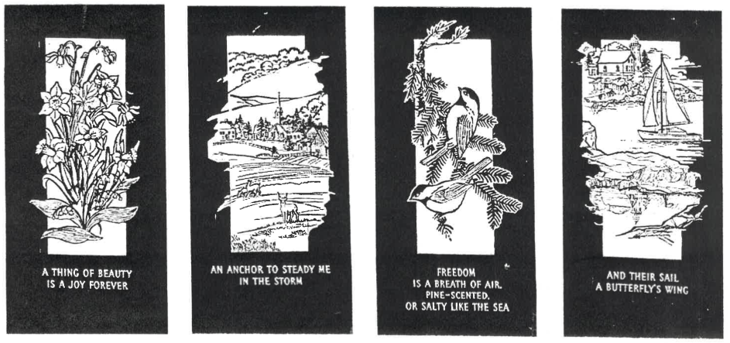

Issued to: ________________________________________________________________________________________________________
Date: _______________________________

